# Design Philosophies

The primary design philosophy is that of consistency and intuitive interactions of the user. A drill down narrative is used with the focus on the map as an overview of the data and the other two visualisations as drilling down into distributions of different factors. Active filters are used to further this goal with the different visualisations serving different filtering functions in as intuitive manner as possible.

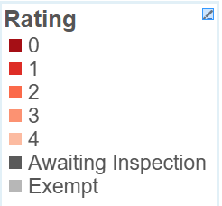The colour scheme was chosen to scale from neutral to red to reflect that the null hypothesis is a good score and red has negative associations (at least in the West). Greys were used to distinguish this quality scale from the two non-numeric values. A tool from colorbrewer2.org generated a colour palette to ensure that it was colour blind and monochrome printer friendly. These conditions come at the cost of some differentiability, some adjacent colours are hard to identify.

Where possible missing and NA values are included in the visualisation. These can themselves yield important patterns and not showing them can mislead the user into confusing missing data and NAs and 0 values. However this often wasn’t possible due to lack of space and limitations with tableau.

Figure Colour Scale used throughout each visualisation (Source colorbrewer2.org sequential Reds n = 6)

Filtering and highlighting within charts are used with caution, we don’t want any new information gated under these as when applied in combination with the active filtering on the dashboard this can confuse users.

# Map

The map visualization gives us an initial qualitative view of the data. It encodes the position of the data points, their rating value and additional information regarding the location of the business (Google Maps).



Figure 2:

Using geocode data provided for each business (Longitude and Latitude) it is possible to uniquely locate each observation. Assigning the Longitude variable to the columns field and the Latitude to the rows, the software assigns a position on the map to any observation of the dataset Figure 3.



Figure 3:

As we produce the map we notice that Tableau report us that the latitude variable has 39 missing values (null values). It has been chosen to filter the corresponding observations as it is impossible to estimate them and it is out of the scope of this project to integrate missing values (it may be possible to retrieve the lacking latitudes from the addresses or postcodes of the same observations).



Figure 4:

We want then to add the business name to each data point as it is a unique identifier and a good label for the viewer (as the map it is by itself an elaborated visualization we want to maintain the tooltip as brief including just name and rating value, the variable of interest). In addition to this we want to visually encode the rating value of the observation by assigning to the 8 possible values of the variable a different colour. The rating value variable is categorical and partially ordinal so we separate the two part and we encode the order as a colour scale. To achieve this, we apply the detail function to the Business Name variable and the colour function to the Rating Value variable.



Figure 5:

For explanatory data analysis purposes it is useful to add a filter on the possible values of the Rating Value variable. This allow us to immediately visualize specific ratings on the map seeking for possible geographical trends. Colours have been designed to stand out and give a quick understanding of the dispersion.



Figure 6:

In the final dashboard it has been decided to include a google map view of the business. Adding precise indications to the data map deceive attention from the data point while this side view not only allow to drill down into location information but also embed updated google data regarding the business including the street view function. It is possible to add this window in the final dashboard by adding a URL action: it is possible to add variables names to the web query so that the map is updated as the user click on the data point on the analytical visualisation.



Figure :



Figure :



Figure :

# Ratings within each postcode

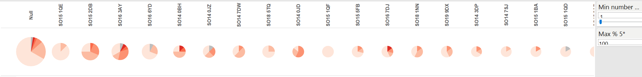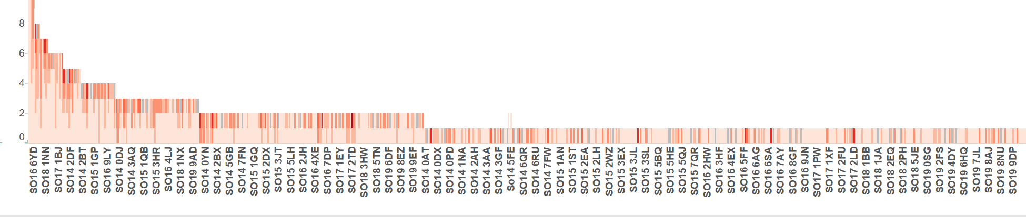There are three main options of visualisation type here: absolute value bar charts takes focus away from the distribution of the postcodes to the density of measurements. Pie charts do not scale well with the large number of postcodes that may be plotted so stacked bar chart is used, although it displays % distribution worse than pie charts and can’t easily encode absolute size values. To make up for this absolute values are present on the tooltip and the postcodes are ordered by absolute size.

Figure Both absolute number of records and percentage distribution (angle) for each postcode encoded in pie charts. Shows percentage distribution most clearly out of 3 options but doesn’t scale with large numbers of postcodes.

Figure 3 Absolute number of records per post code as a bar chart. Primary message of visualisation is distribution within postcodes, absolute value misdirects user focus away from this.

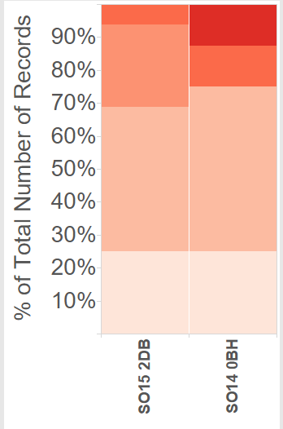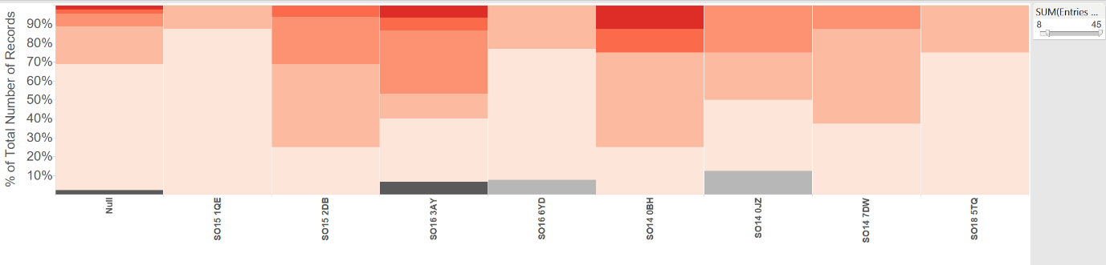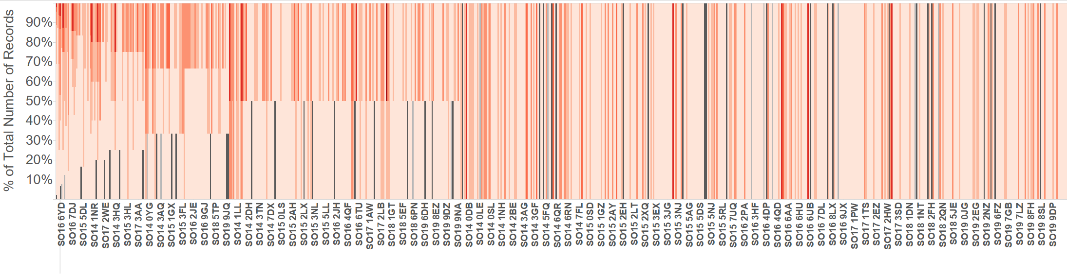

Figure 4 Percentage of postcode records encoded as a stacked bar chart, filtered by a minimum number of records (9). The inclusion of a minimum number of records filter makes the graph clearer by removing postcodes with statistically insignificant numbers of rec

Figure 5 Percentage of postcode records encoded as a stacked bar chart. Keeps focus on distribution while allowing for (messy) inclusion of large numbers of postcodes

Figure 4 is very messy, to clean this a filter requiring a minimum number of records per postcode was made, this was done by created a calculated field of number of records per postcode and filter on it based on a parameter (to produce a slide bar). From here it is clear that SO15 1DB and SO14 0BH are the two postcodes with less than 50% rating 5 while having more than 8 records.

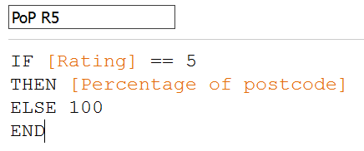

Figure 6: SO15 1DB and SO14 0BH, the two postcodes with more than 8 entries and less than 50% 5 rating.

Figure 7 Postcodes with less than 50% 5 ratings can also be programmatically filtered by creating a percentage of postcode – rating 5 (PoP R5) calculated measure, via creating a percentage of postcode measure and filtering based on a minimum parameter of this value.

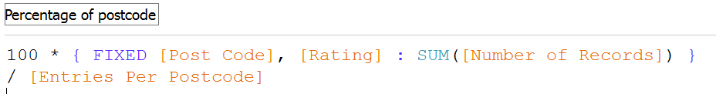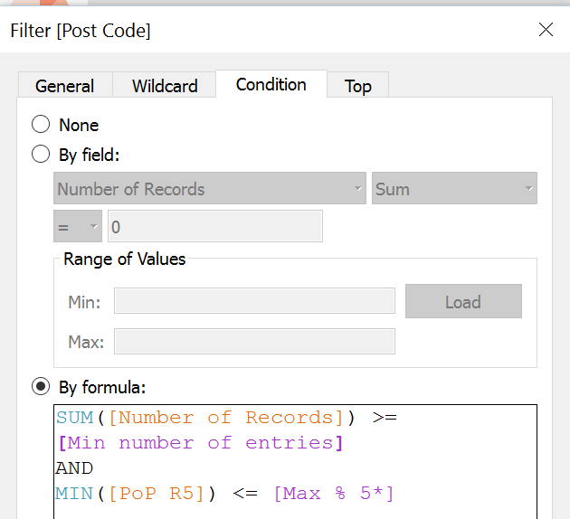

### Breakdown of Business Types

Like before percentage distribution is used rather than absolute values, because the focus is distribution within ratings and absolute values detract from that by focusing attention on more populated ratings, staying consistent between the two also helps avoid confusion. As before absolute values are shown as labels and on the tooltip.

A grouped bar chart was chosen because there are too many businesses to easily interpret a stacked bar chart and this allows for the most accurate visual comparison of business types within a star rating while also allowing comparison of star ratings across businesses. The chart was rotated horizontally because the business types are quite long and need to be read accurately.

Colour was also used internal to the star ratings rather than across business types to keep a consistent colour scheme and to help keep the different ratings distributions visually separate on the graph, without it the internal percentage distributions may be confusing.

Ideally zero recorded value business types would still be present, to clearly communicate a 0 and make distributions consistent but this feature is difficult to achieve in tableau with the “show empty rows” and “show missing values” not achieving this.

An action filter was included on the tooltip to allow users to view only one rating value and see that distribution more clearly. A selection highlighter was used so that on single select like businesses were highlighted, this allows the user to compare one business type’s distribution within a rating.

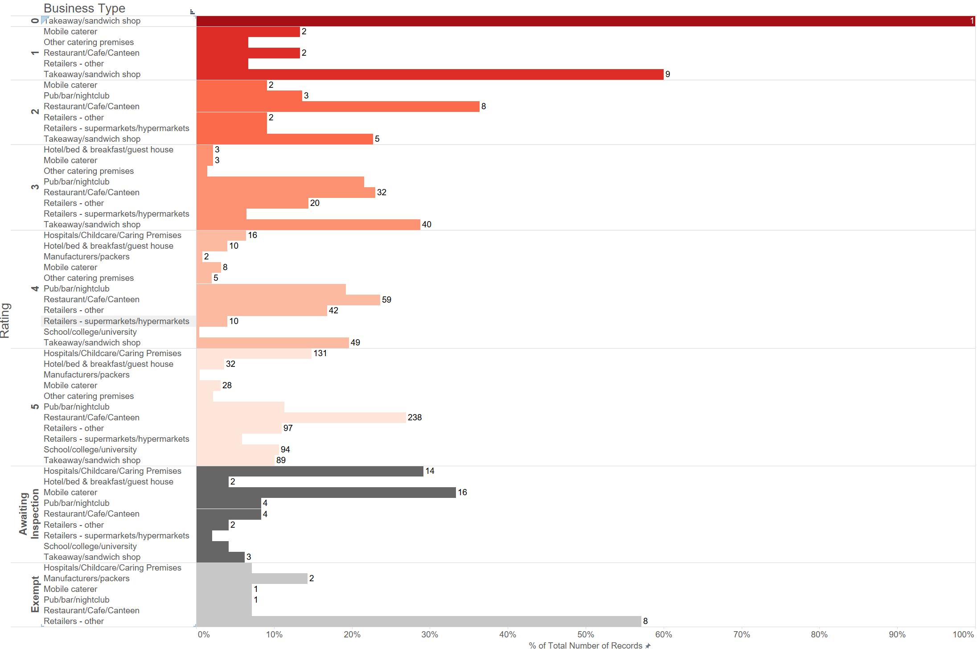

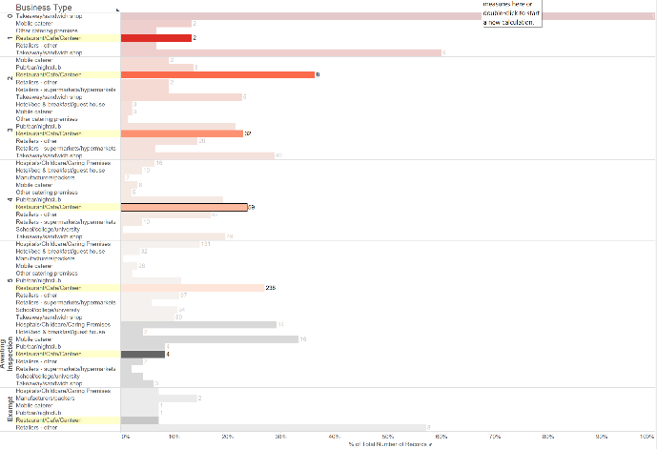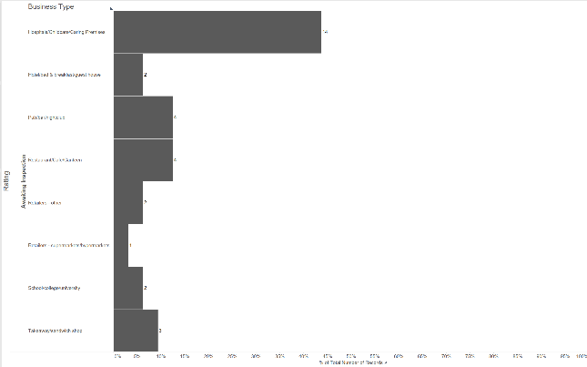Figure : Horizontal grouped bar chart displaying the percentage breakdown of businesses within each rating. (Disclaimer, many of these screenshots are taken on a 4K screen, therefore they may appear especially zoomed out and text smaller).

Figure 8: Distribution of one business type across quality ratings highlighted by a single selection. Multi-selection doesn’t have this effect so custom highlighting and filtering isn’t restricted.

Figure 9: Distribution of businesses within one rating using the “Filter Quality” button. Ideally selecting rating on the left would achieve this but it conflicts with the business action highlighting.

### Dashboard

In designing the final dashboard, the main aim has been optimizing the space available driving at the same time the user in the best possible understanding experience of the data.

The availability of geocode data and so the possibility to effectively locate our observed businesses on a map is a great value of the datasets: the scene is immediately set with clarity thanks to the physical representation of business entities. It has therefore been chosen to put the map in the centre as it represents the starting point for the viewer to understand and interact with the data visualization.

Using the map, it is possible select a specific business or a group. The other graphs change with the selection and the reader’s attention is switched to these parts where it is possible to deepen one’s understanding of the data. On the other hand, synchronization happens in both ways so that the viewer can, at this point, use the bar charts to to look or filter for specific pieces of information.

Finally the Google Map feature on the side of the map allows to immediately retrieve precise and up to date roads, streets and itineraries.

**Layout – map bigger because it is where we want to focus the viewer (drill down narrative, see map, interact with it and look at other visualisations to drill down)**

**Filtering etc.**